# CASE STUDY 1: Term Deposit Analytics

# For Task 1.1: Age Distribution Analytics

This visualization displays the age distribution of clients who made deposits versus those who did not, using a dual-line chart to represent the data. The orange line shows clients who made deposits, while the blue line represents those who did not. The chart highlights key age groups to analyze deposit behavior as part of the segment marketing. We can clearly see the all time high for both categories that the age group of 30-35 are making deposits and the same age group is not making the deposits than any other age group. It does not mean that customers above 35 and below 60 does not have potential to make the deposits.

## Key Findings:

By analysing the chart, I found out that at the age of 32, 221 deposit were made. Contrary to that there were 290 people at the age of 31 not making the deposits.

### Peak Deposit-Making Age Group (30 to 35 years): Reason for Depositing:

This age group typically enters a phase of financial stability, with established careers and a higher likelihood of long-term financial planning, such as savings, investments, or deposits. They might also be settling down, buying homes, or planning for family needs, leading them to prioritize saving.

Marketing Target:

This age group should be the primary target for the bank's deposit marketing campaigns. They are highly responsive and can be approached with messaging that emphasizes future financial security, growth, and benefits of deposits.

### Sharp Decline in Deposits Above 60 Years:

The sharp drop in deposits after 60 (very low orange line) indicates that older clients are less likely to make deposits, while many in this group did not engage at all (blue line stays low).

Target Age Group for Campaigns

Based on the analysis, the 30 to 50 age group should be the core target for deposit marketing. This group shows a balance between financial stability and responsiveness to deposit offers. Marketing strategies could highlight security, competitive interest rates, and long-term financial planning. The below 30 and above 60 age groups can still be addressed with more specialized products, but they are not the ideal audience for deposit marketing.

# For Task 2.1: Career Impacts On Deposits

This bar chart compares the likelihood of clients from different job categories to make a deposit ("Yes") or not make a deposit ("No"). The chart is split into two sections: the left side shows the count of clients in each job who did not make a deposit, while the right side shows those who made a deposit.

## Key Insights:

### Management:

* Highest Deposit Participation: Clients in management positions are the most likely to make deposits, as indicated by the tall green bar on the "Yes" side.
* However, a significant number of management clients also did not make a deposit (shown by the tall green bar on the "No" side), indicating potential untapped opportunities for this group.
* Interpretation: Management clients are generally financially stable, making them more inclined to save and invest, but further engagement could target those who haven't made deposits yet.

Blue-Collar and Technicians**:**

* Moderate Deposit Participation: Clients in blue-collar jobs and technician roles have a moderate likelihood of making deposits, but many also did not make deposits (the light blue and teal bars are almost equal in height on both sides).
* Interpretation: These job categories may have lower disposable income or less inclination toward savings, but they should still be considered in marketing campaigns, particularly with messaging around accessible and flexible deposit options.

### Admin and Services:

* Balanced Deposit Behavior: Clients in admin and services roles show a balanced behavior, with a substantial number making deposits but also a large proportion not making deposits.
* Interpretation: This group might respond well to targeted marketing campaigns, especially if the messaging emphasizes long-term savings and financial security.

### Retired Clients:

* High Deposit Likelihood: A notable number of retired clients made deposits (tall green bar on the "Yes" side) compared to those who didn’t.
* Interpretation: Retired clients may prefer safer, guaranteed returns, making them more likely to engage in deposit products.
* This group should be targeted with conservative financial products like fixed deposits.

### Self-Employed, Entrepreneurs, and Students:

* Low Deposit Participation: Self-employed, entrepreneurs, and students show much lower participation in making deposits, as shown by shorter bars on the "Yes" side. A higher proportion of these groups did not make deposits.
* Interpretation: These groups may face financial uncertainty (self-employed and entrepreneurs) or may lack disposable income (students). Marketing strategies could focus on educating these groups about the benefits of saving and providing flexible deposit options.

# For Task 1.3: Contact Duration Analytics

## Key Insights from the Visualizations:

* Impact of Contact Duration: The visualizations clearly show that the duration of the last contact has a significant influence on whether a client subscribes to a deposit.

Longer calls (especially those lasting more than 500 seconds) tend to result in more positive outcomes (i.e., "yes" for deposits). This is supported by the higher average contact duration among clients who subscribed.

* Short Calls Lead to Fewer Deposits: Shorter calls, especially those under 300 seconds, are predominantly associated with negative outcomes (i.e., clients not subscribing to a deposit). This highlights that shorter engagements are less likely to convert into deposits.
* Scatter Plot Visualization Reinforces Duration's Impact: The scatter plot further emphasizes that longer contact durations increase the likelihood of a deposit subscription.

Contacts lasting more than 500 seconds consistently show more positive outcomes. Most unsuccessful campaigns cluster around shorter call durations, which are less effective in generating subscriptions.

* Spread of Longer Calls: While the number of calls exceeding 1500 seconds is smaller, these longer interactions still contribute to more successful deposits. Calls ranging between 1000 to 2000 seconds have a steady success rate but occur less frequently.
* Concentration of Data Points: The majority of successful deposit subscriptions occur between 200 to 1000 seconds of call duration, making this duration range the most effective for campaign success.

### Conclusion:

Longer calls generally lead to higher conversion rates, with a clear improvement in success rates occurring around 500 seconds of call duration. In contrast, calls shorter than 300 seconds rarely lead to positive outcomes. The importance of longer client engagements to improve the chances of securing deposits in future campaigns. These findings suggest that maintaining longer contact durations during marketing calls is essential for improving campaign success rates.

## For Task 1.4: Campaign Strategies:

### 1. Who to Contact:

* Marital Status:

Married individuals tend to have higher positive outcomes for deposits, with 2,755 successful deposits compared to other groups. Focus marketing efforts on married clients.

Divorced individuals are the least likely to subscribe, so they may not be a priority target.

* Education:

Secondary and tertiary educated clients show higher success rates for deposits, with 2,450 deposits from secondary education and 1,996 from tertiary.

Prioritize targeting these education levels. Primary education level has the lowest success rate, suggesting less emphasis on this group.

* Age: Clients aged 25–60 represent the highest proportion of the customer base and are more likely to subscribe to deposits. We can focus on this age group for higher success.

### 2. How to Contact:

* Communication Channels: Cellular contact is the most effective method, with 4,369 deposits from cellular contacts. It shows consistently high success rates compared to other methods. Telephone contact has relatively low success, making it less efficient, while the unknown method also underperforms. Cellular should be the main focus.

### 3. When to Contact:

* Monthly Insights: May and August are the most successful months for deposits, with May having the highest number of successful campaigns. Focus on these months for major campaigns. December and January are the least effective months, indicating reduced activity during these times.
* Day of the Month: There’s variability in success rates across different days. Peaks in successful deposits occur mid-month (around days 10-20), suggesting campaigns should intensify during this period for better outcomes.

### 4. Customer's Financial Profile: Balance:

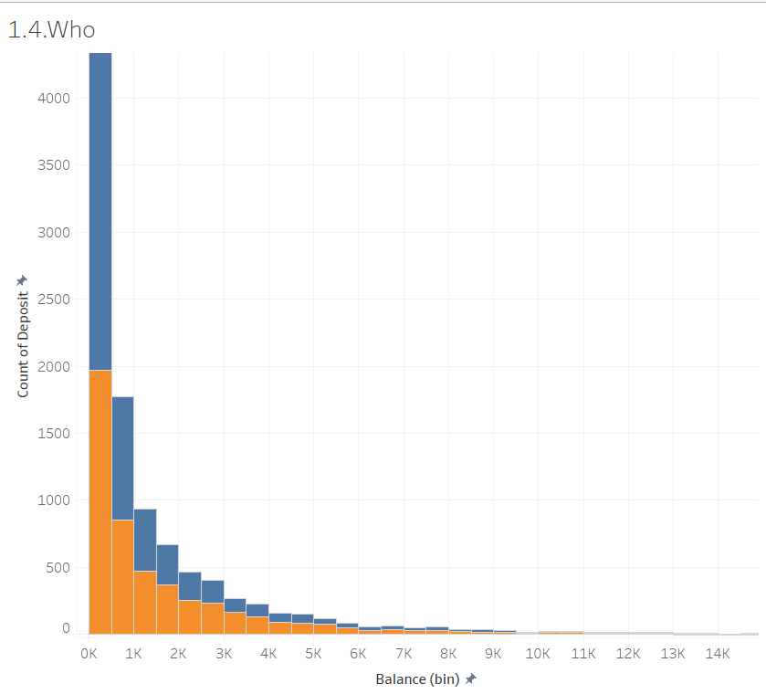

Clients with low balances (0-1K) still generate significant deposits, with 1,972 + 854 deposits from clients with <=1k balance. However, we can clearly see that the deposits decline as the balance increases beyond 5K, suggesting that marketing efforts should focus on clients with lower balances (under 5K), as they’re more likely to subscribe to deposits.

### Key Recommendations:

Target married individuals with secondary or tertiary education in the age range of 25-40. Use cellular contact as the primary communication channel, as it has the highest conversion rate. Launch intensive marketing campaigns in May and August, with a focus on the mid-month period. Focus on clients with balances under 5K, as they show the highest likelihood of subscribing. These strategies can be translated into actionable insights for improving marketing effectiveness and increasing deposit subscription rates.